Assignment 2

1. Write a program which accepts a sequence of comma-separated numbers from console and

generate a list.

**CODE:**

**#Assignment 2**

**Num = input("Input sequence of comma separated numbers : ")**

**lst = Num.split(",")**

**print('List : ',lst)**

**OUTPUT:**

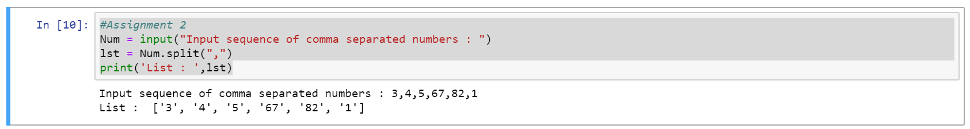

2. Create the below pattern using nested for loop in Python.

*

* *

* * *

* * * *

* * * * *

* * * *

* * *

* *

*

**CODE:**

**for i in range(5):**

**print("* "*i, end="")**

**print("")**

**for i in range(5,0,-1):**

**print("* "*i,end="")**

**print("")**

**OUTPUT:**

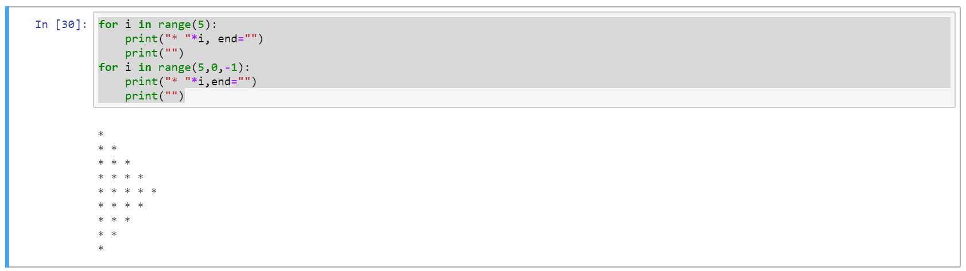

3. Write a Python program to reverse a word after accepting the input from the user.

Sample Output:

Input word: AcadGild

Output: dilGdacA

**CODE:**

**#Assignment 2**

**string = input("Enter the string to be reversed:")**

**revstring = string[len(string)::-1]**

**print("The reversed string:",revstring)**

**OUTPUT:**

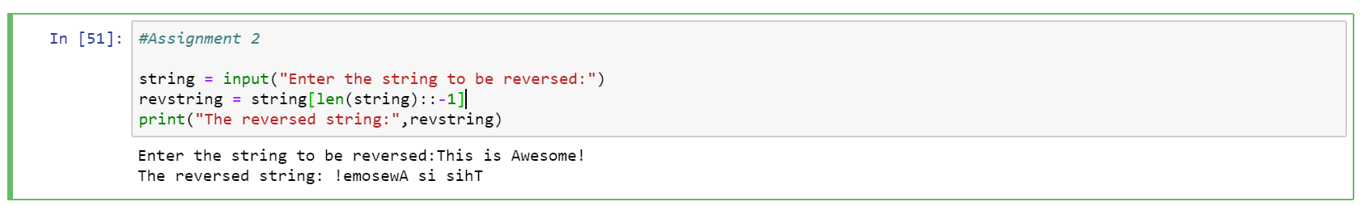

4. Write a Python Program to print the given string in the format specified in the sample

output.

WE, THE PEOPLE OF INDIA, having solemnly resolved to constitute India into a SOVEREIGN,

SOCIALIST, SECULAR, DEMOCRATIC REPUBLIC and to secure to all its citizens

Sample Output:

WE, THE PEOPLE OF INDIA,

having solemnly resolved to constitute India into a SOVEREIGN, !

SOCIALIST, SECULAR, DEMOCRATIC REPUBLIC

and to secure to all its citizens

**CODE:**

**#Assignment 2**

**sample = """WE, THE PEOPLE OF INDIA,\nhaving solemnly resolved to constitute India into a SOVEREIGN,!**

**SOCIALIST, SECULAR, DEMOCRATIC REPUBLIC\nand to secure to all its citizens**

**"""**

**print (sample)**

**OUTPUT:**

